Space Shuttle Ultra
Centaur G and
Centaur G Prime
Reference

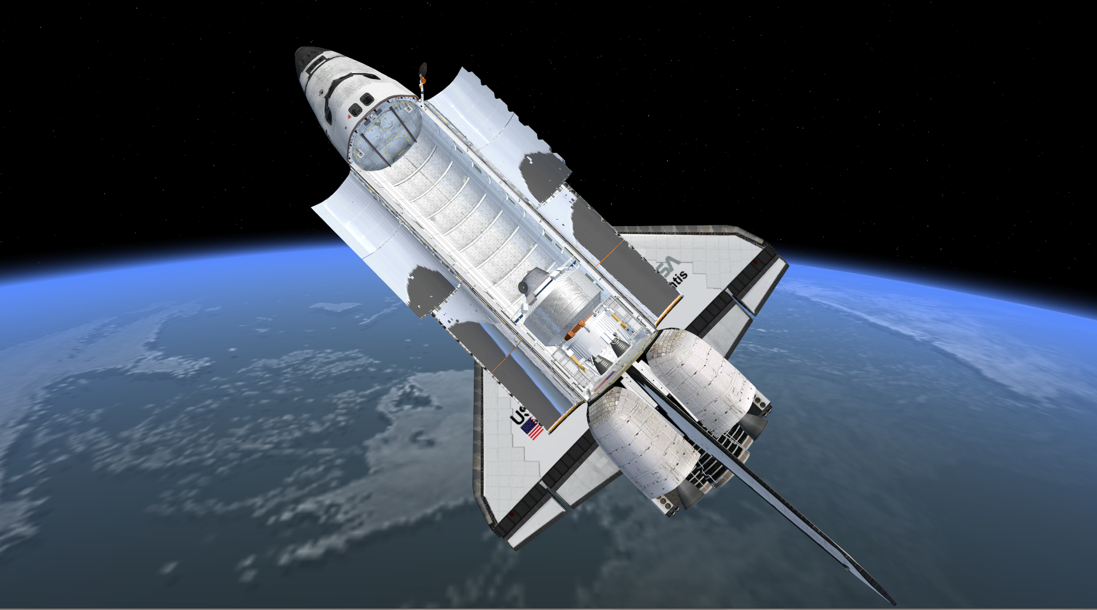

Introduction

The Space Shuttle Ultra team is proud to present the Centaur G and Centaur G Prime stages. This allows the Space Shuttle Ultra to launch payloads to anywhere from GEO to the depths of the Solar System.

Background

In the 1980s, NASA and General Dynamics/Convair Division developed 2 versions of the Centaur upper stage for use in the Space Shuttle. The Centaur G version was developed primarily for GEO satellite deployment missions, and the more powerful Centaur G Prime for interplanetary payloads. In the aftermath of the Challenger accident, both versions were cancelled for safety reasons.
The Centaur is carried inside the Space Shuttle’s payload bay, and is supported by the CISS (Centaur Integrated Support System), which also acts as an interface between the Centaur and the Space Shuttle.

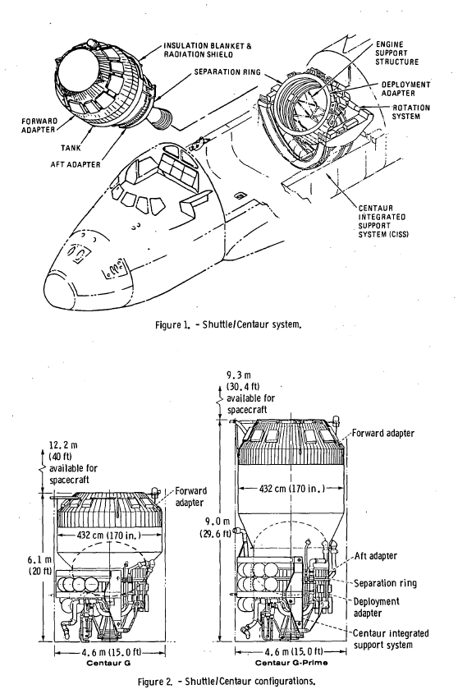

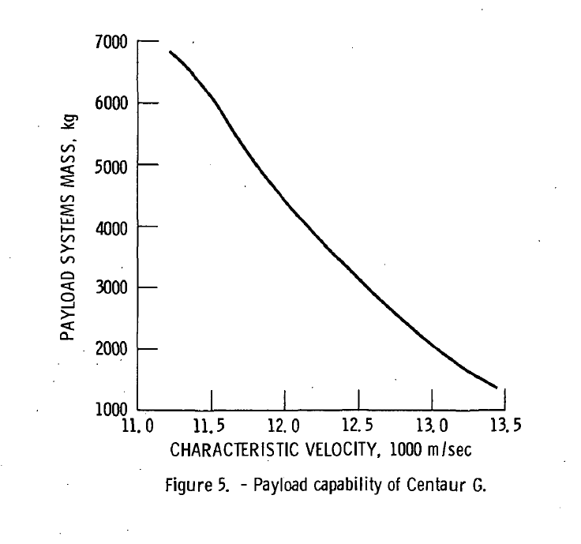

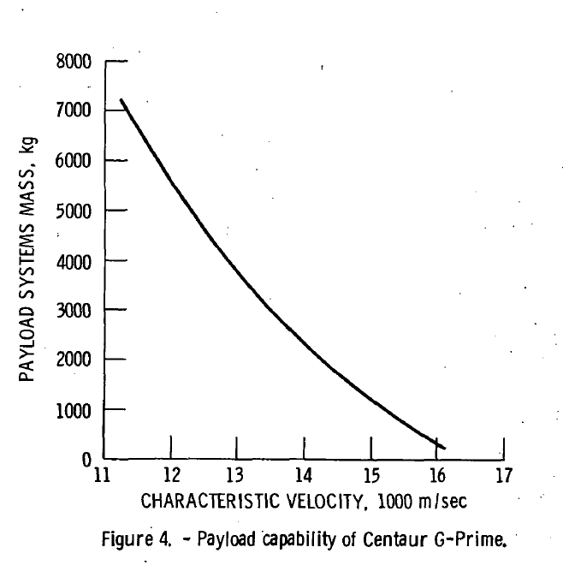

Payload capabilities of the Centaur G Prime/Centaur G

Deployment sequence

After the Space Shuttle Orbiter has achieved orbit, and the payload bay doors have been opened, the deployment of the Centaur with its payload can be started.
The deployment sequence of the Centaur begins with the rotation of the CISS/Centaur adapter to the raised position. After this is complete, the separation of the Centaur can occur. The user must be in the CISS vessel to perform these operations.
The Centaur ACS (Attitude Control System), and the RL-10 engines are inhibited for the first 5 minutes after Centaur separation, as well as while the Centaur is attached to the CISS. This allows for Centaur to move to a safe distance from the Space Shuttle Orbiter. After 5 minutes the user is given control of all the engines in the Centaur, thus allowing vehicle maneuvering and RL-10 engine burns using the default keys.
After the Centaur has achieved the desired trajectory, the payload can be released, finishing the Centaur’s job.

Keys

 | Key | Action
Centaur | J | Separate payload
CISS | G | Raise adapter
CISS | L | Lower adapter
CISS | J | Separate Centaur

Adapter

The connection between the Centaur and the payload is done using an adapter. The adapter is specified in the Centaur vessel section of the scenario file by using the following 3 entries:
- ADAPTER_MESH - defines the path and filename of the mesh file of the adapter;
- ADAPTER_OFFSET - defines the offset between the Centaur and the payload in meters (effectively the height of the adapter);
- ADAPTER_MASS - defines the mass of the adapter in kilograms.
On payload deployment, the adapter remains with the Centaur.

<insert adapter diagram and more detail on the attachment???>

Flight Operations – Generic

- Orbiter (099 or 104 will be the Shuttle Orbiter modified for Centaur. Galileo (GLL) takes advantage of the additional performance capability of 104.
- Centaur/spacecraft shall be a dedicated payload, and as such, need not consider other payload/requirements during the same STS mission.
- Centaur flight operations shall provide for crew initiation of critical events. The events include Centaur unlatch, rotation (up and down), and separation.
- The crew will switch the Centaur Cargo Element (CCE) power to the Orbiter power supply after ascent of the full 3.2 kW is not available from the Orbiter during the ascent phase.
- Centaur will perform an inertial platform rotation while attached to the Orbiter that will occur midway between launch and Centaur MECO.
- Orbiter OMS and translation RCS shall be inhibited for deployment adapter rotation, and for Centaur separation. Orbiter primary and vernier RCS is to be inhibited during Centaur separation.
- Centaur separation shall occur in daylight.
- Centaur separation system shall impart a minimum of 1 fps relative velocity between the Centaur and Orbiter. (The RMS will not be used.)
- Centaur RCS shall not be armed until a distance of 200 ft (an elapsed time of 5 minutes) has been achieved after separation from Orbiter.
- Centaur propellant tank pressurization and vent systems shall be inhibited before separation until after Centaur RCS is enabled.
- No provisions shall be made for the Orbiter crew and ground operations to inhibit and re-enable the vehicle arming sequence via RF link.
- Centaur main engine system shall not be armed until an elapsed time of 45 minutes has been achieved after separation from the Orbiter.

Flight Operations – Mission Peculiar

- The Ulysses (ISPM) and GLL missions shall be launched in May-June 1986.
- Spacecraft attitude-thermal constraints are: (1) no direct sunlight in Orbiter payload bay with short duration exceptions, and (2) a thermal slow-roll (0.1 rpm) until RTG booms are deployed.
- During post-separation, until pre-Main Engine Start (MES) coast, spacecraft discreets (GLL only) are to be issued by Centaur.
- Centaur shall reorient for separation then achieve a high spin (2.9 rpm); dependent upon S/C mass properties/cross products of inertia.

Contingency Operations – Generic

- In event of an abort, Centaur main propellants (LO2 and LH2) shall be dumped before return.
- Orbiter RCS propellant settling thrust shall provided to initiate and terminate Centaur propellant dump for Abort From Orbit (AFO) abort. The Orbiter OMS thrust shall be used for Centaur propellant dump for Abort Once Around (AOA) aborts.
- Centaur systems shall permit simultaneous dump of LO2 and LH2 propellants with in 250 sec during Return To Launch Site (RTLS) and Trans-oceanic Abort Landing (TAL) abort.
- Centaur propellant abort dump shall be automatic during RTLS, TAL, and AOA aborts, with a manually initiated back-up option.
- Centaur is to continue mission in case of an Abort To Orbit (ATO) abort that does not affect capability to complete mission successfully.
- Abort preferences are: ATO over AOA, and AOA over TAL.
- Centaur systems shall accommodate a worst-case, closed-door abort thermal environment. Such an abort consists of the Orbiter payload bay doors remaining closed continuously with the duration from lift-off to landing of 6.5 hours.
- Mission will be aborted if cargo bay doors are not opened within three hours Mission Elapsed Time (MET).

Feedback

Any bugs should be reported in the Space Shuttle Ultra section of the Orbiter-Forum website (www.orbiter-forum.com).

